**Top 10 grossing hyper-casual games in 2020**

**Hyper-Casual games and their journey from History to Today.**

Bored of the day? Need something to freshen up your mind? Have only a few minutes for entertainment? Want something space-friendly on your device? Answer to all your issues is Hyper-Casual games.

A tap and here you are….ready to play! Spontaneous user interface with awesome user experience is all here with these games. These are the perfect formula for enhancing the time utilization for perfect refreshment. This arrangement is perfect with any time-span of minutes or hours, whichever you prefer with your working schedules.

Diminished entanglements are the sole success behind these. Hyper-casual game developers have ensured trouble-free, space-effective, and effortless features in these games, guarantying more gross results and easier accessibilities for the players.

Below is how the hyper-casual game concept broke out to the globe with the variant releases in each step:

Let’s have a look at how the hype of Hyper-casual games resulted in the boost in its market and gross results.

* In 2018, hyper-casual games made unrivaled growth jumping ahead 48.5%, encircling 510 million active users monthly. The CPI was $0.15 for hyper-casual games in android and $0.36 for iOS, increasing to $0.18 (+6%) & $0.47 (+29%) respectively over the past 6 months.
* In consumer spend over mobile games, hyper-casual games account for over 74% expenditure amount.
* At the top game charts, 9/10 games are hyper-casual.
* Downloads have increased from 100 million per month in 2015 to 600 million per month in 2019.

**Top-grossing hyper-casuals in 2020**

As mentioned in SensorTower’s survey, these are the few top-grossing hyper-casual games as on May 2020 survey:

1. **Coin Master** – Your fortune is a spin away! This game makes you win various prizes and rewards by spinning a wheel and landing on your luck. There is a treasure hunt too to be won in this. The app experienced over 11 million downloads and 36million USD revenue generation as of May 2020.

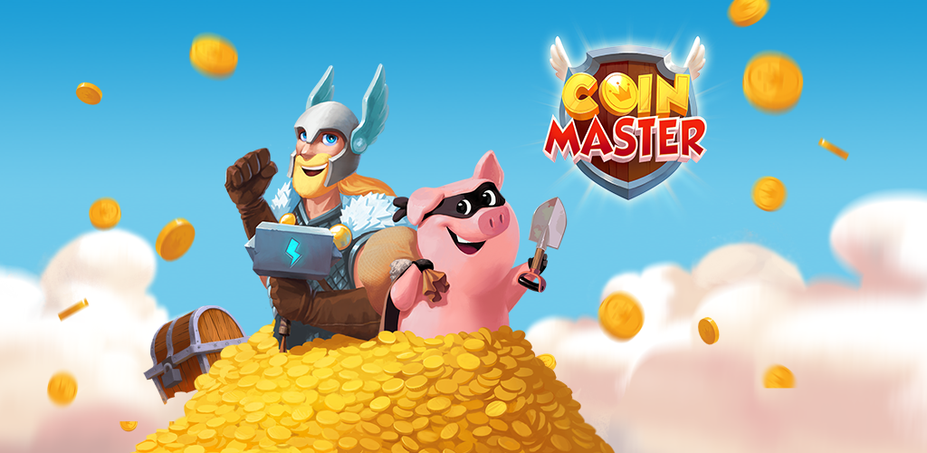

1. **Gardenscapes** – Decorate your gardens according to the stories being told. In Gardenscapes you can get creative by decorating with various available facilities after earning from another game available within the app. I suppose the *twenties* have been lucky numbers for Gardenscapes. As, in May 2020, it got 22 million downloads and 25 million $ revenue generation.

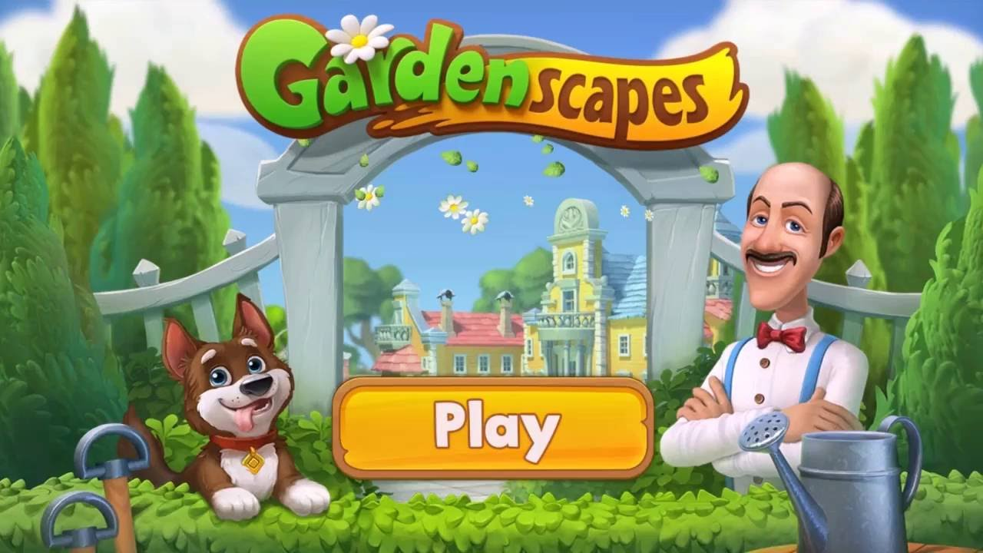

1. **Candy Crush Saga** – A puzzle game with sweets varieties. Switch, match, and boom! And just like that, with each blast, you are a step closer to the victory. In May 2020, there were over 12 million downloads for the app. Candy Crush Saga generated a revenue of $18 million in May 2020.



1. **Best Fiends- Free Puzzle Game** – I haven’t misspelled! Best fiends is a puzzle adventure 5-star rated game. Solve puzzles and beat the bad guys in the magical world of minutia. App generated $4 million of revenue and received 600k downloads in May 2020.

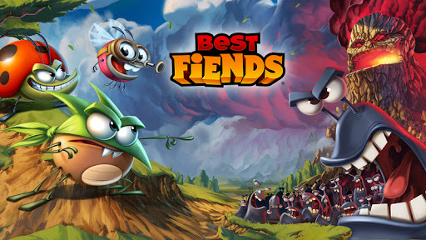

1. **Hay Day** – Want to do farming? Hay day is the perfect choice for you. Develop your farms, and do fishing around the valley. Build heavenly land in the game. This hyper-casual game had 2 million downloads and over 4 million USD revenue generation in May 2020.



1. **Board KingsTM** – Roll the dice and play to win. With each roll, you get to develop a board city. Secure your city, destroying others’ and stealing stuff. In May 2020, this app got 700k downloads and $3 million revenue generation.

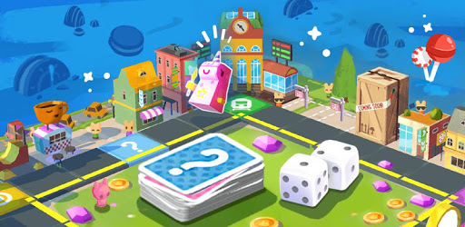

1. **FarmVille 2: Country Escape**  - Farm adventures got a go these days. Visit FarmVille and farm, collect goods, and pursuit various formulas. FarmVille 2 as of May 2020, had 900k downloads and a good amount of revenue generation of $1000 thousand.

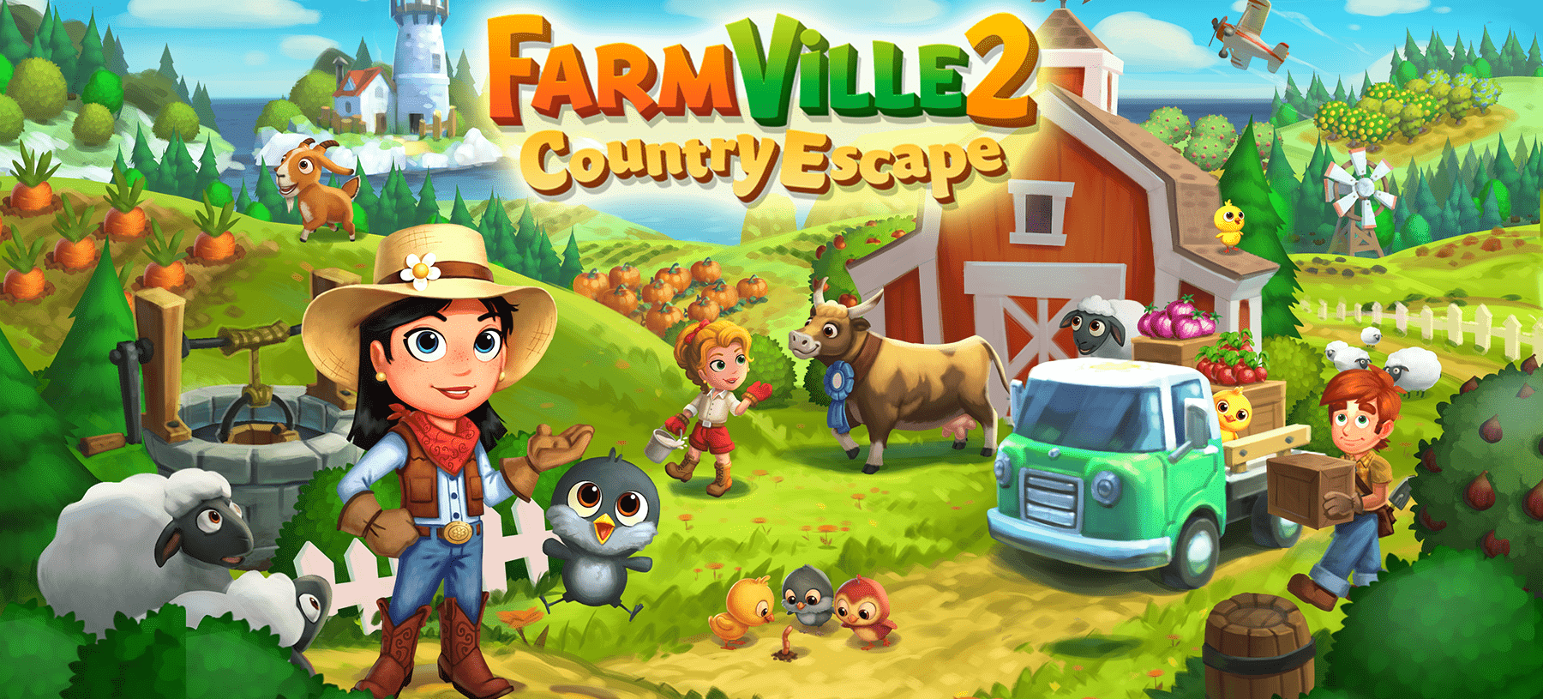

1. **The Battle Cats** – The Battle Cats from PONOS Corporation is a battlefield game. Tap on the cute cats you want on your side and fire on the others. Unlock the levels and help these cats evolve. This app experienced over 200k downloads in May 2020, and also generated revenue of $400 thousand.



1. **Bubble Shooter** -Pop and Pop and strike and Blast! Are you too a fan of shooting bubbles and making them pop and blast? Bubble Shooter is the most classic and addictive game for fun doing. It comes in various modes for playing, and every few days, there is a quest going on in the app. This fascinating game had 8 million downloads in May 2020 with a revenue generation of $300k.

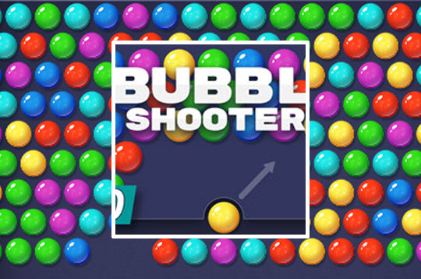

1. **Hunter Assassin** – Be a terminator in this Assassination game. Be an assassin controller in this hyper-casual game and hunt down the enemies taking the help of the shadows in hiding from their flashes. Each execution produces gems, collecting which unlocks the faster assassins. Hunter Assassin got 19 million downloads and $30k in revenue generation in May 2020.

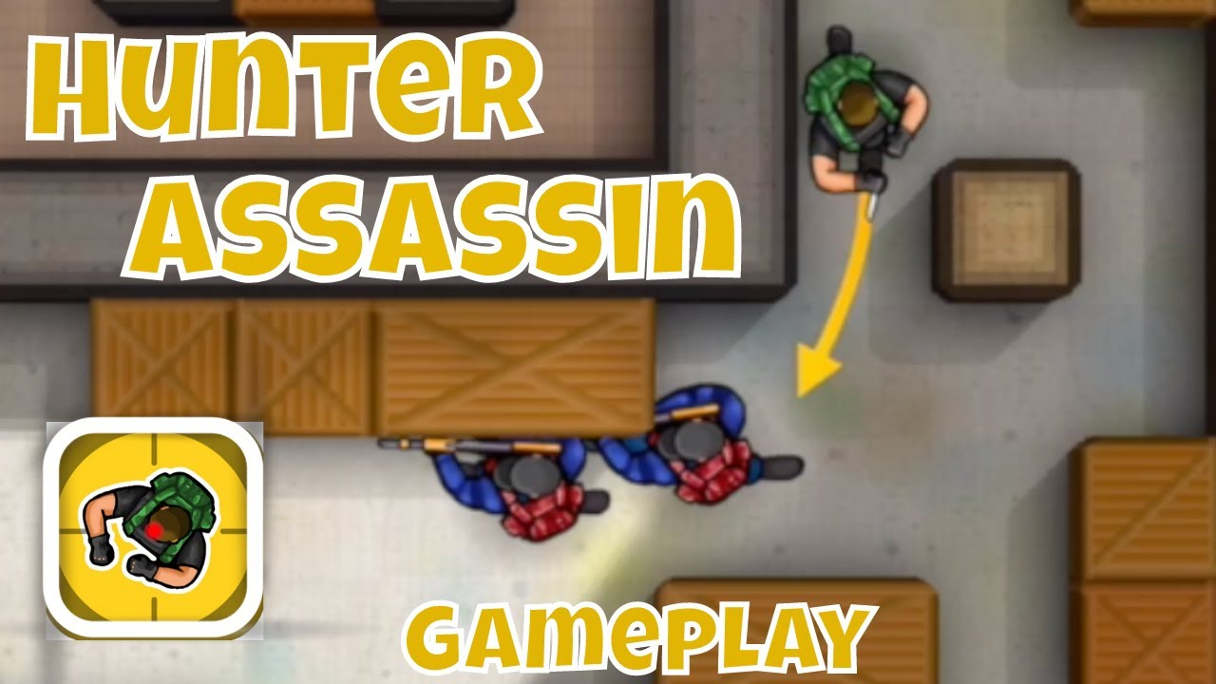

**Mechanics involved in Hyper-Casual game development**

1. **AGILITY mechanism** – Most known hyper-casual games Pacman and Snakes use agility mechanisms. Catch the objects and with each catch, pace up a bit.
2. **MERGE mechanism** – In the merge mechanism merging of similar types using cell, swapping is required. The most commonly used hyper-casual game with this mechanism is Candy Crush Saga.
3. **PUZZLE mechanism** – 60% in-app purchases depend on the Puzzle mechanisms. In 2018, puzzle mechanism games reaped $3.8 billion.
4. **Social mechanism** – Social networking plays a crucial role in this technology type. We can connect with social media friends while playing a game, and can also compete with them. Remember Farmville? The social mechanism was its building block.
5. **SWERVE mechanism** – Move on the track, and avoid the hurdles, straying over the screen. Temple Run and Subway Surfers are similar concepts where the death traps are to be avoided.
6. **TIMING mechanism** – This mechanism enables a time limit on your levels. Coordination between various game components is the key to winning. An example of such a mechanism is in the game Breakout where we handle the ball with a platform, breaking the bricks above it.

**Fulfilling monetization, a basic necessity…**

The global audience and extensive revenue generation are accomplished by a few strategies as mentioned.

* In-app purchases (used in both premium as well as freemium apps).
* Cross-promotion
* Premium Apps
* Advertising ( in 2018, it accounted for 56% revenue generated by in-app purchases)

**Hyper-Casual game development via Game App Studio**

The well-experienced team from Game App Studio can provide you with extensive and profitable features with satisfactory and fully-functioning applications. Technologies used by the developer team are Unity, Buildbox, GameMaker Studio 2, Cocos2D, and SpriteKit. Features that we can help you achieve are:

1. Lightweight app with easy accessibility
2. Social logins
3. Tap and play games
4. Leader board
5. Social media sharing
6. Invitations
7. In-app purchases

We, at Game App Studio, specializes in multi-platform mobile application development and mobile games for both Android and iOS.